**Year 10 Rapid Reactions Quiz 1 Revision**

1. Complete the terms for each definition below:

|  |  |
| --- | --- |
| Term | Definition |
| Atomic number | Number of protons in the nucleus of an atom |
| Mass number | Number of protons and neutrons in the nucleus of an atom |
| Valence electrons | Number of electrons in the outside shell of an atom |
| Group | Vertical column in the periodic table |

1. Label the atom below and complete the table.

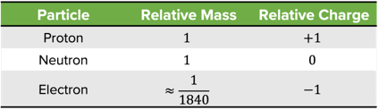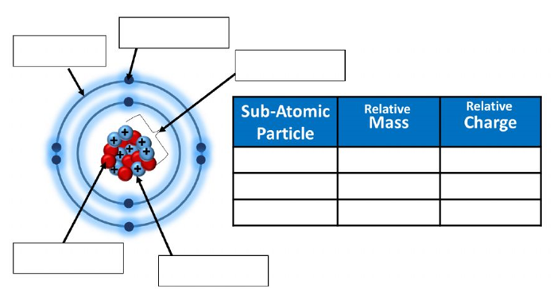

proton

neutron

nucleus

electron shell

electron

1. Complete the table below

|  |  |  |  |  |  |
| --- | --- | --- | --- | --- | --- |
| **Atom** | **Name of Element** | **Atomic Number** | **Mass Number** | **Number of Electrons in Neutral Atom** | **Number of Neutrons** |
| $$\begin{matrix}23 \\ 11\end{matrix} Na$$ | sodium | 11 | 23 | 11 | 12 |
| $$\begin{matrix}35 \\ 17\end{matrix} Cl$$ | Chlorine | 17 | 35 | 17 | 18 |
| $$\begin{matrix}27 \\ 13\end{matrix} Al$$ | Aluminium | 13 | 27 | 13 | 14 |
| $$\begin{matrix}19 \\ 9\end{matrix} F$$ | Fluorine | 9 | 19 | 9 | 10 |
| $$\begin{matrix}80 \\ 35\end{matrix} Br$$ | Bromine | 35 | 80 | 35 | 45 |

1. Complete the table below

|  |  |  |  |
| --- | --- | --- | --- |
| **Symbol** | **Number of Electrons** | **Electron Configuration** | **Electron Configuration diagram** |
| F | 9 | 2,7 |  |
| P | 15 | 2,8,5 |  |
| Si | 14 | 2,8,4 |  |
| Na+ | 10 | 2,8 |  |
| Ca2+ | 18 | 2,8,8 |  |
| Cl- | 18 | 2,8,8 |  |

1. Explain the difference between a **period** and a **group** in the Periodic Table. What do each of these tell us about the properties of elements?

* A group is a column of the periodic table and tell us the number of valence electrons in an atom. Atoms in each group have similar properties.
* A period is a row of the periodic table and tells us the number of electron shells an atom has

1. A student conducted an experiment and made the following observations:

* Potassium is more reactive than sodium
* Sodium is more reactive than aluminium
* Fluorine is more reactive than bromine

**Explain** these observations using the diagram of the periodic table below.

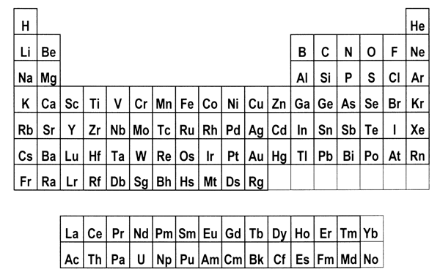

* Potassium is lower on the periodic table than sodium. Reactivity of metals increases as the periods increase.
* Sodium is further left on the periodic table than aluminium. Reactivity of metals increases from right to left on the periodic table.
* Fluorine is above bromine on the periodic table. Reactivity of non-metals decrease as the periods increase.

1. Complete the following table below for each bonding type by sorting the given terms into the correct row.

|  |  |  |  |  |
| --- | --- | --- | --- | --- |
| Left, Centre and Right | Soft if solid | Shared electron pairs | High for solids | Low to high |
| Left and Centre | Brittle and hard | Oppositely charged ions | Not as solids but does when molten | High |
| Right | Malleable | Delocalised electrons and positive ions | Not as solids or liquids | Usually low |

|  |  |  |  |  |  |
| --- | --- | --- | --- | --- | --- |
| Type of Bonding | Periodic Table location | Structure | Bond contains: | Conductivity | Melting Point |
| Metallic | Left and Centre | Malleable | Delocalised electrons and positive ions | High for solids | High |
| Ionic | Left, Centre and Right | Brittle and hard | Oppositely charged ions | Not as solids but does when molten | Low to high |

1. In terms of bonding, explain why copper can be stretched into wires but copper chloride cannot.

Copper has metallic bonding which are positive ions surrounded by a sea of delocalised electrons. As the atoms are stretched, the delocalised electrons move with the atoms, electrostatically still holding the structure together.

Copper chloride is an ionic substance that has a lattice structure made up of alternating positive and negative ions. When the copper chloride is stretched, ions of like-charge are forced to come close together. The repulsion force of like-charges is enough to break the lattice apart.

1. Complete the following table by writing the correct chemical formula for each compound formed.

|  |  |  |  |  |
| --- | --- | --- | --- | --- |
|  | FLUORIDE | NITRIDE | CARBONATE | PHOSPHATE |
| POTASSIUM | KF | K3N | K2CO3 | K3PO4 |
| MAGNESIUM | MgF2 | Mg3N2 | MgCO3 | Mg3(PO4)2 |
| AMMONIUM | NH4F | (NH4)3N | (NH4)2CO3 | (NH4)3PO4 |
| ALUMINIUM | AlF3 | AlN | Al2(CO3)3 | AlPO4 |
| LEAD IV | PbF4 | Pb3N4 | Pb3(CO3)4 | Pb3(PO4)4 |